

GREYHAVEN - PR campaign (January 2017 – 2017)

{ RELEASE ARTWORK }

Overview:

The promotional campaign for targeted key figures within the UK music industry ranging from prominent printed press, influential journalists and radio stations through to independent magazines and established websites.

The overall feedback for this campaign has been . We secured national magazine and widespread online exposure for the band. Many major printed publications are now also greatly aware of the band and we’ve obtained numerous reviews for the record with many popular websites and independent magazines.

This campaign has increased the band’s national profile and has laid down essential foundations for the future. With regards to moving forward, we would strongly advise a continued promotional presence by releasing an EP or album as soon as you possibly can. It is recommended that you arrange national digital distribution (i.e. with iTunes, Spotify, Amazon, Google Play, etc) to help support the next release, and if you organised a UK tour to coincide with the record this would further enhance responses from media outlets. We look forward to working with the band again.

Conclusion:

The successes of this campaign included:

- Radio airplay with:

EGH Rocks – spot play (30/1/17) - www.eghradio.com

Axe Rock Radio – spot plays (31/1/17) – see below notes.

Wayout Radio – spot plays: as discussed, http://www.wayoutradio.co.uk/

- Online coverage/news/interviews and feedback from influential websites such as:

Breathing The Core – news: http://www.breathingthecore.com/2017/01/news-greyhaven-brother.html#

Muzak – news: https://muzakreview.wordpress.com/2017/01/26/greyhaven-prepare-to-reveal-explosive-new-video/

Regards,
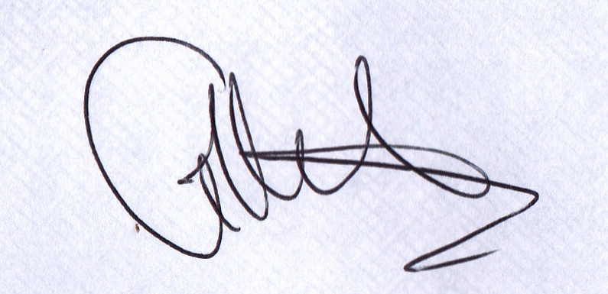

Garry Hutchinson.

Head of SaN PR.

AXE ROCK RADIO AIRPLAY

The Playlist from The New Rock Show
Friday Nights at 8pm

Repeated Sunday Night at 8pm

10 Rogue Know Better

Greyhaven Brother

Hellbound Hearts Suffering The Radio

Thunder Rip It Up

The Wild Ready To Roll

Larre U A Spinning Wheel

Slaves (US) Id rather see your star explode

My Son The Bum Mad Man

White Lies Don’t Want to feel it

Edenbridge Shiantara

